Computer Networks - Kurose and Ross
Resources: https://raw.githubusercontent.com/gsahinpi/acm361/master/Computer%20Networks%20-%20A%20Tanenbaum%20-%205th%20edition.pdf
https://www.youtube.com/watch?v=5D67Qy1tPLY&list=PLLFIgriuZPAcCkmSTfcq7oaHcVy3rzEtc
TODO
- https://sites.cs.ucsb.edu/~almeroth/classes/F04.176A/homework1_good_papers/Alaa-Gharbawi.html
- https://www.usg.edu/galileo/skills/unit07/internet07_03.phtml

Introduction

What is the Internet ?
The Internet is a computer network that interconnects hundreds of millions of computing devices throughout the world.
Components:
- hosts (devices on internet: comp, mobile, router, any device on internet)
- links (connection – wired, not-wired)
- routers (special type of host: job is make path (path selection) for data)
- protocols (rules/contracts implemented by hosts)

Internet provides
- communication infrastructure
- communication services such as reliable data delivery (TCP) and “best effort” data delivery (try its best to deliver data example: IP)

Protocol
- rules for interaction
- defines: format. Order and actions

Network edge devices → access networks/physical media → network core

Network edge
- devices are devices that are accessible to end uses (smartphones, laptops)
- models of communication: client/server and peer to peer (everybody is client and server and everybody can talk to everybody)
End devices are connected together by a network of communication links (coaxial cables, copper wire, optical fiber) and packet switches (routers, link layer switched). When one end system has data to send to another end system the sending system segments the data add headers to each segment. The result is know as packet which are then sent through the network to the destination end system, where they are reassembled into the original data.
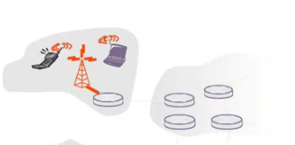
Access Networks and physical media

How to connect network edge device to edge router ?
- Residential (home) access networks (DSL, cable modems – it is not telephone line, it is TV line, fiber)
- institutional access network
- mobile access networks (for phones 3G. 4G. 5G)
DSL - digital subscriber line
When DSL is used a customer telco is also its ISP. Use the existing telephone line to exchange data with DSLAM – digital subscriber line access multiplexer (located in the telco’s local office). Separates the data and phone signals (phone call) and send data into Internet.
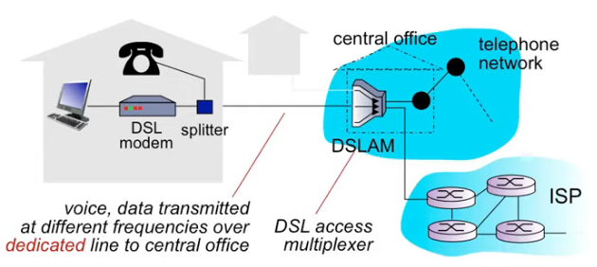
Cable Internet access makes use of the cable television company’s existing cable tv infrastructure.
When cable internet is used a customer cable television company is also its ISP. Because both fiber and coaxial cable are employed in this system, it is often referred as hybrid fiber coax (HFC)
Cabel Modems
- an external device that connects home PC to internet through an Ethernet port
- have shared access (on the same subnet)
Fiber to the home (FTTH) – optical fiber from the CO to the home. Each fiber leaving the central office is actually shared by many homes, it I not until the fiber gets close to the homes that it is split into individual customer fibers. It can be active optical network (AONs) or passive optical network (PONs)
WIFI (wireless) access point with router (router firewall, NAT) are often combined in one device.
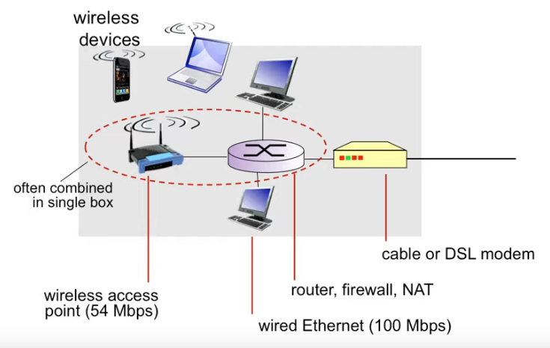

Enterprise Access Network same principle as residential/home but more components. Ethernet is most used LAN technology were uses use twisted pair copper wire to connect to an Ethernet switch then the Ethernet switch (or a network of interconnected switches) is connected into larger Internet.
Also there is a wireless LAN (WiFi – based on IEEE 802.11)
End systems access the Internet through Internet Service Provides (ISPs) including ressidential ISPs such as local cable or telephone companies, corporate ISPs. Each ISP is in itself a network of packet switches and communication links.
Physical Media
- guided media – wired (twisted pair TP, coaxial cable, fiber optic cable)
- unguided – wireless (terrestrial microwave, LAN – wifi. Wide area – cellular. Satellite)

Network core
How is data transferred through the net (moving data) ?
- Circuit switching (dedicated circuit – virtual for every connection, between sender and revicer)
- Packet switching (send data in packets)
Circuit switching
- end to end connection
- reservation of resource along the path (like telephone call). Set up in the physical layer and used for direct data transmissions through a dedicate channel (streams like voice transmission)
- at the physical layer routes the complete message via the dedicated channel built when setting up the connection. Because data is delivered and received in streams, this kind of switching isn’t optimal for data transfer since the line would be inactive between transmission waves
- The three phases in the circuit switching protocol include the connection establishment phase, the actual data transfer phase, and the connection termination phase.
- FDM – frequency division – like radio (give me connection at specific frequency)
- TDM – time division – each user gets time slot and repeat it.
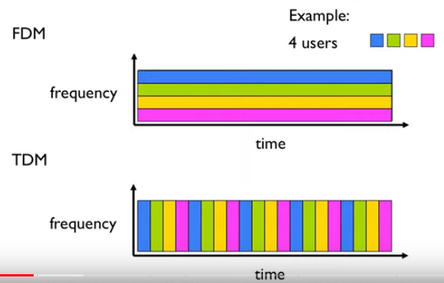

Packets switching
- break all of data into chunks of data (packets)
- use resources and needed – no reservation
- use full sped every time
- if you try to send more then can be send – you ‘ll need to wait (loose packets or loose speed)
- also called statistical multiplexing
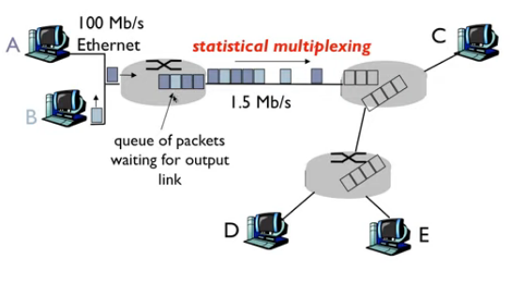

Problem: 1 Mb/s link, each user 100kb/s when active, active 10% of time
Circuit Switching: 10 users
Packet Switching: how many users at same time ? On active network if you have lots of users packet switching is better, but problem is data, if lots of data, we have lots of data or time, there is also situation that we need to provide circuit-like behavior (like video) in packet switching.
Circuit switching is a connection-oriented network technique (much like transmission control protocol or TCP), while packet switching is a connectionless network switching method. This means that for circuit switching, there must be an actual creation of the network path through which information will pass. Circuit switching uses a handshake method referred to as a reliable network service
Circuit switching does not handle bilateral traffic easily, while the packet switching technique makes bilateral traffic go as smoothly as possible
The layers used by circuit-switched networks and packet-switched networks are different. The circuit network is implemented at the physical layer, whereas the packet-switched network is implemented at the network layer.
Circuit switching uses time and space division switching, while packet switching uses the datagram and virtual circuit approaches

Networks of Networks (Internet Structure)
Current network structure is driven by economy (money) and national interests.
Access IPSs → Multi-tier → complex
Given millions of access ISPs, how to connect them together ?
End systems access the Internet through Internet Service Provides (ISPs) including ressidential ISPs such as local cable or telephone companies, corporate ISPs. Each ISP is in itself a network of packet switches and communication links. The access ISP can provide either wired or wireless connectivity, using an array of access technologies including DSL, cable, FTTH, Wi-Fi, and cellular.
The Internet is all about connecting end systems to each other so the ISPs that provide access to end systems must also be interconnected. These lower-tire IPSs are interconnected through national and international upper tiers ISP . An upper tier ISP (global ISP) consists of high speed routers interconnected with high-speed fiber optic links- Each ISP network whether upper tier or lower tier is managed independent runs the IP protocol and confirms to naming and address conventions.
End systems, packet switches and other pieces of the Internet run protocols of control for sending and receiving of information. The TCP (Transmission Control Protocol) and the IP are two of the most important.
Connect access points to Tire 1 ISP-es (in image ISP A, B, C) give access to global internet. (ISP in the same tire (Tire 1) are interconnected using peering link) Also there are IXP (Internet exchange point – third party companies ) where they link some tiers (ISP A , ISP B)
Often there are regional net which connects access net points to Tire 1 ISP-es (network between access net and Tire 1 ISP network. If you comps needs to talks with someone from regional net there will not be need to send data through Tire 1 (some type of hierarchy).
To build a network that more closely resembles today’s Internet, we must add
- points of presence (PoPs)
- multi-homing
- peering,
- Internet exchange points (IXPs) to the network.
A PoP is simply a group of one or more routers (at the same location) in the provider’s network where customer ISPs can connect into the provider ISP.
Any ISP may choose to multi-home, that is, to connect to two or more provider ISPs.
Pair of nearby ISPs at the same level of the hierarchy can peer, that is, they can directly connect their networks together so that all the traffic between them passes over the direct connection rather than through upstream intermediaries.
Along these same lines, a third-party company can create an Internet Exchange Point (IXP) (typically in a stand-alone building with its own switches), which is a meeting point where multiple ISPs can peer together.
Content provider network – big companies – connect they servers to users to be faster for uses also cheaper to them. The Google data centers are all interconnected via Google’s private TCP/IP network, which spans the entire globe but is nevertheless separate from the public internet. (Google is not paying Tire 1 to send data it has its own network – but it is connected to needed networks.)

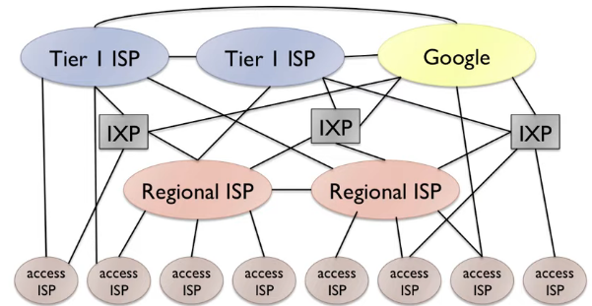
In summary, today’s Internet—a network of networks—is complex, consisting of a dozen or so tier-1 ISPs and hundreds of thousands of lower-tier ISPs. The ISPs are diverse in their coverage, with some spanning multiple continents and oceans, and others limited to narrow geographic regions. The lower-tier ISPs connect to the higher-tier ISPs, and the higher-tier ISPs interconnect with one another. Users and content providers are customers of lower-tier ISPs, and lower-tier ISPs are customers of higher-tier ISPs. In recent years, major content providers have also created their own networks and connect directly into lower-tier ISPs where possible.

Delay loss and throughput

Each packet switch has multiple links attached to it. For each attached link, the packet switch has an output buffer (output queue) which stores packets that the router is about to send into that link.
How does the router (packet switch) determine which link (destination) should forward the packet onto ?
Every end system (device) has an address (IP). Source includes the destination IP address in the packet’s header. When a packet arrives at a router in the network it examines a portion of the packet’s destination address and forwards the packet to an router. Each router has a forwarding table that maps destination addresses (or portions of the destination address) to that router’s outbound links. When a packet arrives at a router the router examines that address in forwarding table to find the appropriate outbound link. The router then directs the packet to this outbound link. The end-to-end routing process is analogous to a car driver who does not use maps but instead prefers to ask for directions.
Internet has a number of special routing protocols that are used to automatically set the forwarding tables.
Visit the http://www.traceroute.org/
How do loss and delay occur ?
Router can send at specific speed and specific amount of data (packet per seconds). If arrival rate in router is faster than sending rate then router puts packets into queue.
Types of delay
- transmitted delay – time to put data to wire (when sending)
- queueing delay – time spent in queue
- propagation – time to signal to move across the medium (router, wire) – small time, it is fast
- processing – computation that router is doing (figure output link, check errors ...)

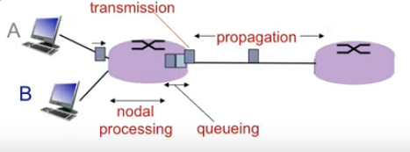

Delay = processing delay + queuing delay + transmission delay + propagation delay
Loss when queue is full but in router packets are arriving
It is possible to receive first bit at router B even router A has not received last bit.
Traffic intensity = La/R – how bits can be send to router
L – packet length (bits)
a – average packet arrival rate (packet per seconds)
R – link bandwidth (bps)
if result is closed to zero then we have good speed (no delay) and we can send packets but if result is closed to 1 delay will be large. If result is bigger than 1 then we are slow and there is not help
see: traceroute program
If buffer (queue) is full packet is lost (if new one arrives then it is lost – no place to store it). Lost packet can be resend (depends on the protocol)
Throughput rates (bits/time unit) at which bits transferred between sender and receiver. Instantaneous – value at some point at time. Average – value overr some period.
If server speed is less than client speed. Then speed is server.
If client speed is less than server speed. Then speed is client speed.
Bottleneck link - Link on end-end path that constraint end-end throughput (slowest node in link – network)
If you have n clients and n servers they are connected using one pipe (internet) what is throughput ?

Protocol Layers

Stao
→ https://www.youtube.com/watch?v=acN7sjkYoKo&list=PLLFIgriuZPAcCkmSTfcq7oaHcVy3rzEtc&index=5

